MODULE: 1 ASSIGMENT: 1

(1) what is software? what is software engineering?

Software is a collection of computer programs and related data that provide

the instructions for telling a computer what to do and how to do it.

software engineering engineering-style system of software development.

A software engineer is a person who applies the principles of software engineering

to design, develop, maintain, test, and evaluate computer software.

(2) Explain types of software.

**System Software**

System software provides the basic functions for computer usage and helps

run the computer hardware and system.

**Programming Software**

Programming is the process of designing, writing, testing, debugging, and

maintaining the source code of computer programs. This source code is

written in a programming language. The purpose of programming is to

create a program that exhibits a certain desired behavior.

**Application Software**

Application software is the general designation of computer programs

for performing user tasks.

(3)what is SDLC? explain each phase of SDLC.

The Software Development Life Cycle (SDLC) refers to a methodology

with clearly defined processes for creating high-quality software

phase of SDLC

1. Requirement Gathering

2. Analysis

3. Designing

4. Implementation

5. Testing

6. Maintenance

<1> Requirement Gathering :- Requirement gathering is the first phase they are important to gather

all data and requirements.

<2> Analysis :- analysis the part of the phase they are use to analysis market and other work formation.

<3> designing :- creat designing both of geather requriment and analysis.

<4> implementation :- implementation are the they designing and put in the market how they work etc.

<5> testing :- testing is the same as the implemantation and change like current situations.

<6> maintenance :- maitenace are like all phase are to cover and changes so they are need to maintenance.

(4) what is DFD? creat a DFD diagram on flipkart.

DFD- Data Flow Diagrams

Graphical representation of flow of data inside application.

Used for visualization and data processing.

DFD elements are:

◦External Entity

◦Process

◦Data Flow

◦Data Store

1) External entity:

Can be user or external system that performs some

process or activity in project Symbolized with rectangle.

If we have entity ‘admin’ then symbol will be

e

2) Process:

Work or action taken on incoming data to produce

output

Each process must have input and output

Symbolized as.

3) Data Flow

Can be used to show input and output of data

Should be named uniquely and don’t include word ‘data’

Names can be ‘payment’, ‘order’, ’complaint’ etc.

Symbolized as

4) Data Store

Can be used to show database tables Only process

may connect data stores

There can be two or more process sharing same data

store

Symbolized as.

V

(5) what is flow chart? create a flowchart to make addition of two numbers.

Used to show algorithm or process . Can give step solution to the problem

• The first flow chart was made by John Von Newman in 1945

• Pictorial view of process

• Flowcharts are generally drawn in the early stages of formulating computer solutions.

• Flowcharts facilitate communication between programmers and business people. These flowcharts play a vital role in the programming of a problem and are quite helpful in understanding the logic of complicated and lengthy problems.

• Once the flowchart is drawn, it becomes easy to write the program in any high level language.

•Often we see how flowcharts are helpful in explaining the program to others. Hence, it is correct to say that a flowchart is a must for the better documentation of a complex program.

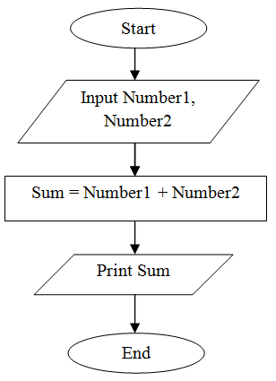

(6) what is use case diagram? Create a use-case on bill payment on paytm.

A use case diagram is a graphical depiction of a user's possible interactions with a system. A use case diagram shows various use cases and different types of users the system has and will often be accompanied by other types of diagrams as well. The use cases are represented by either circles or ellipses. The actors are often shown as stick figures.

